
Guidance

ASSESSING LOW- CARBON TRANSITION

Multi-activity assessment






version 1.0 – November 2024

technical coordination



Supported by

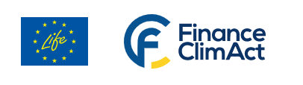

Technical assistance provided by



© ADEME & WBA 2024. Reproduction of all or part of work without licence of use permission from ADEME & WBA is prohibited.

Content

1. Introduction 4
2. Definitions 5
3. How to assess 6
3.1. Top-down approach 6
3.1.1. Targeted companies 6
3.1.2. Methodological rules 6
3.2. Bottom-up approach 7
3.2.1. Targeted Companies 7
3.2.2. Methodological rules 8
3.2.3. Scope & boundaries at Business unit level 12
3.2.4. Scoring consolidation at Group level 14
3.2.5. Communication 17
4. Glossary 17
5. Appendix 1 – feedback from ACT roadtests 18
6. Appendix 2 – Methodological frameworks used 20

Introduction
One of the ambitions of ACT initiative is to propose evaluation tools to all existing companies in order to help them to initiate or strengthen their low carbon transitions. ACT project first focused on key sectors for the low-carbon transition with significant contributions to global GHG emissions and developed sector-specific methodologies (ACT sectoral methodologies). In addition, an ACT Generic methodology has been developed, covering the rest of the sectors not yet covered by an ACT methodology. ACT road-tests that have been implemented have highlighted a few operational problems, especially regarding companies with multiple activities that would need to use several ACT sectoral methodologies in parallel.
In order to address operational issues of multi-activity companies, and to allow ACT assessments to be applicable to every type of organizations, additional guidance has been developed.
This guidance on multi-activity assessment includes rules on the definition of the scope (which activities or business units to cover) and on how to aggregate several ACT scores obtained by the same company for several of its activities. The rules are based, where possible, on existing international standards, such as the GHG Protocol or the EU taxonomy. Also, they cover the assignment of performance, narrative and trend ACT scores per business unit.
Creating this guidance is not a simple task, due to the complexity and heterogeneity of multi-activity companies. Several challenges need to be taken into account:
- Reach the right balance between pragmatism and consideration of material GHG emissions: make data collection as easy as possible while focusing on the main sources of GHG emissions and ensuring that the large majority of the GHG emissions are taken into account.
- In a company with multiple activities, identify the levels (holding company, business unit, …) where the decarbonisation levers and decisions making processes are situated. The decarbonisation levers can be distributed at different levels of such a multi-dimensional organization. For instance, the holding company may have the power of decision on customer strategy or investments, whereas R&D budgets are in the hands of its business units. The decarbonisation levers are presented in the figure below.
- The overall group’s ACT score (e.g. holding company’s ACT score) should be consistent with and representative of the activities of its business units.

In this regard, all the rationales meet two crucial objectives:
- Consider as much as possible the reality of the company, i.e. its organization and its GHG emissions profile,
- Facilitate the logistics of the data collection process.

The multi-activity rules may be used for all companies, but two specific cases will require them:
- Extending a company’s ACT assessment to other business units or to group level, whereas the assessment primarily concerned one or several business units.
- Assessing a multi-activity company at group level

In order to adapt to capture the diversity of corporate profiles and expectations, two methodologies are available and will be further detailed in this document:
  - The top-down approach, which follows the ACT Generic methodology.
  - The bottom-up approach, which can mobilize all ACT methodologies.

Preamble
In preparation for an ACT assessment, the assessor is highly encouraged to elaborate a detailed overview of:
- the group’s activities breakdown
- the degree of autonomy of each of its business unit (or the distribution of emissions reduction levers between the group and its business units),
- the contribution of each type of activity / business unit to the group’s total revenue,
- the contribution of each type of activity / business unit to the group’s total GHG. emissions (GHG inventory).

Important note on the ACT feedback report
The ACT feedback report should specify the reporting boundary and scope of activities considered within the specific assessment, in quantitative manner (e.g. split of revenue from activity and/or GHG emissions).

Definitions
The multi-activity company as a whole is referred to in this document as a group.
Each subsidiary with a certain degree of autonomy is called a business unit.
Holding company refers to the group as the legal structure (company) that owns or controls the business units.
Group level refers to the holding company level, which should be the highest level in the group (top management), above the business units.
Business unit level refers to the management of the business unit.
One business unit may also own sub-subsidiaries with various activities. As explained later in the document, the same organization structure is applied: the business unit becomes a holding company which owns/controls others sub-business units.
A typical structure of a multi-activity company is included in Figure 2.

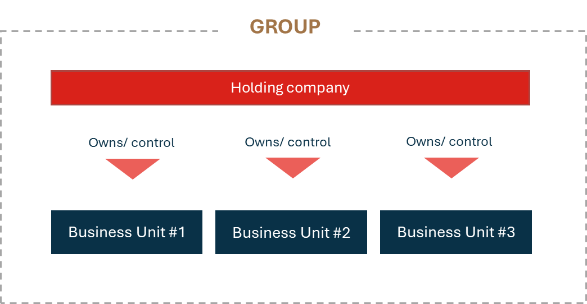
Figure 2 - Structure of a multi-activity company
All concepts are precisely defined in the glossary.

How to assess

Top-down approach

Targeted companies

The top-down approach is suitable for assessing:
- Integrated companies whose activities are all covered by ACT Generic methodology,
- Companies which consider setting a target only at group level, without going through an activity/business unit approach.
- Companies which do not report detailed data at the level of their business units and therefore do not have the visibility to apply sector-based methodologies.
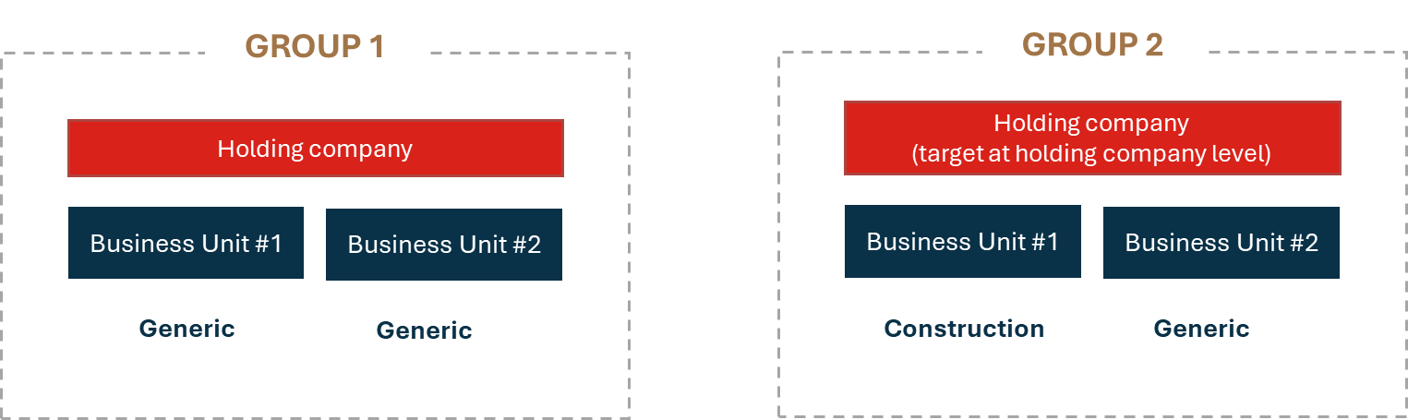
Figure 3 - Illustration of targeted companies for top-down approach

Methodological rules
The top-down approach works by applying ACT Generic methodology at the Group level, without distinguishing its activities or business units. The ACT generic methodology is based on the identification of the main GHG emissions sources and levers at disposal of a company.
The data collection process is conducted according to the requirements of ACT Generic methodology at Group level and one complete ACT score (performance, narrative and trend) will be given at Group level, as any other organization scored using ACT Generic assessment. The business units will not get ACT scores at their own level.

➔ Rationale
- The top-down approach can be considered as a first “introduction” to ACT methodology, targeting “beginner” groups which do not have / disclose data on their contribution and impact on climate change at subsidiary level. This approach allows them to elaborate a first rough low-carbon transition assessment.
- This approach is adapted to highly integrated groups which do not want to opt for a sectoral approach.
- This approach is suitable for groups whose different activities do not cover emissions intensive sectors (i.e. not targeted by ACT sectorial methodologies).

However, the top-down approach is not precise and therefore not highly relevant. It may be useful as a first mapping or for integrated companies where all the decarbonisation levers are in the hands of the holding company. Otherwise, the bottom-up approach is recommended.

Bottom-up approach

Targeted Companies
The bottom-up approach is suitable for assessing:
- Companies whose activities are (partially or totally) covered by ACT sectoral methodologies,
- Companies for which one or several business units have already been ACT scored,
- Companies whose activities are divided into separate business units.
Figure 4 - ILLUSTRATION OF TARGETED COMPANIES FOR bottom-up APPROACH

Methodological rules

Disclaimer: all the rules announced below are minimum requirements. The assessors which follow the multi-activity rules are encouraged to go beyond and achieve the most comprehensive coverage possible.

Scope & boundaries at Group level

Rule n°1: Definition of activities/business units covered by ACT assessment

The business units that must be covered by an ACT Assessment shall meet all the following criteria:
  - #1: Be at least 20% owned by the holding company,
  - #2: Represent at least 5% of the group’s total revenue and 5% of the group’s total GHG emissions (scope 1+2+3)
OR
Be considered by the assessor as material and should therefore be included in the assessment scope. The assessor can use and challenge the materiality assessment required by European CSRD regulation if the group is subject to it.
E.g.: The business unit represents a strategic business for the future of the group.
E.g.: The business unit has material scope 3 emissions, but this is not included because GHG inventory is not complete.
  - #3: In total, at least 80% of the group’s total emissions must be covered.

The assessor should pay attention to the robustness of the GHG inventory and availability of data at business unit level when defining the scope.
Two illustrations of scope definition at group level are presented below.
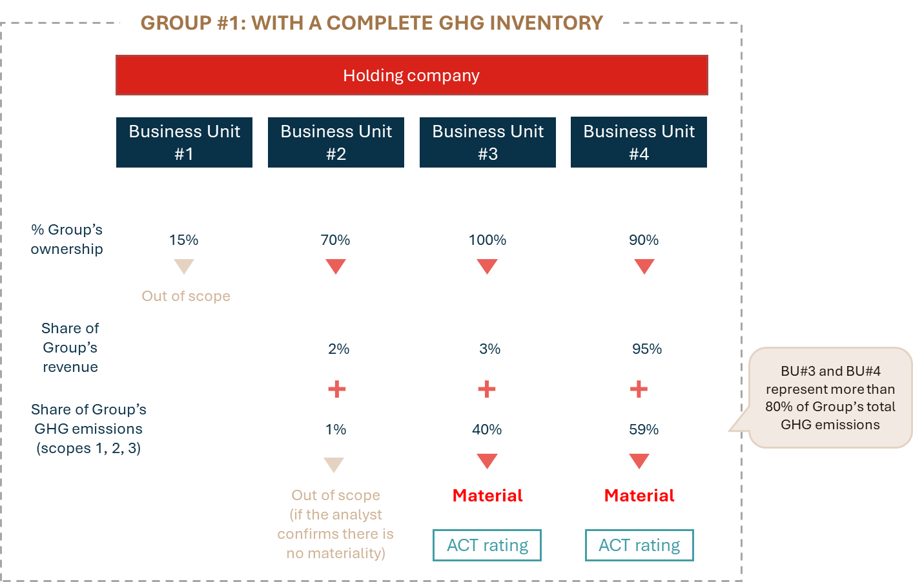
Figure 5 - Definition of ACT assessment scope when GHG inventoty is complete
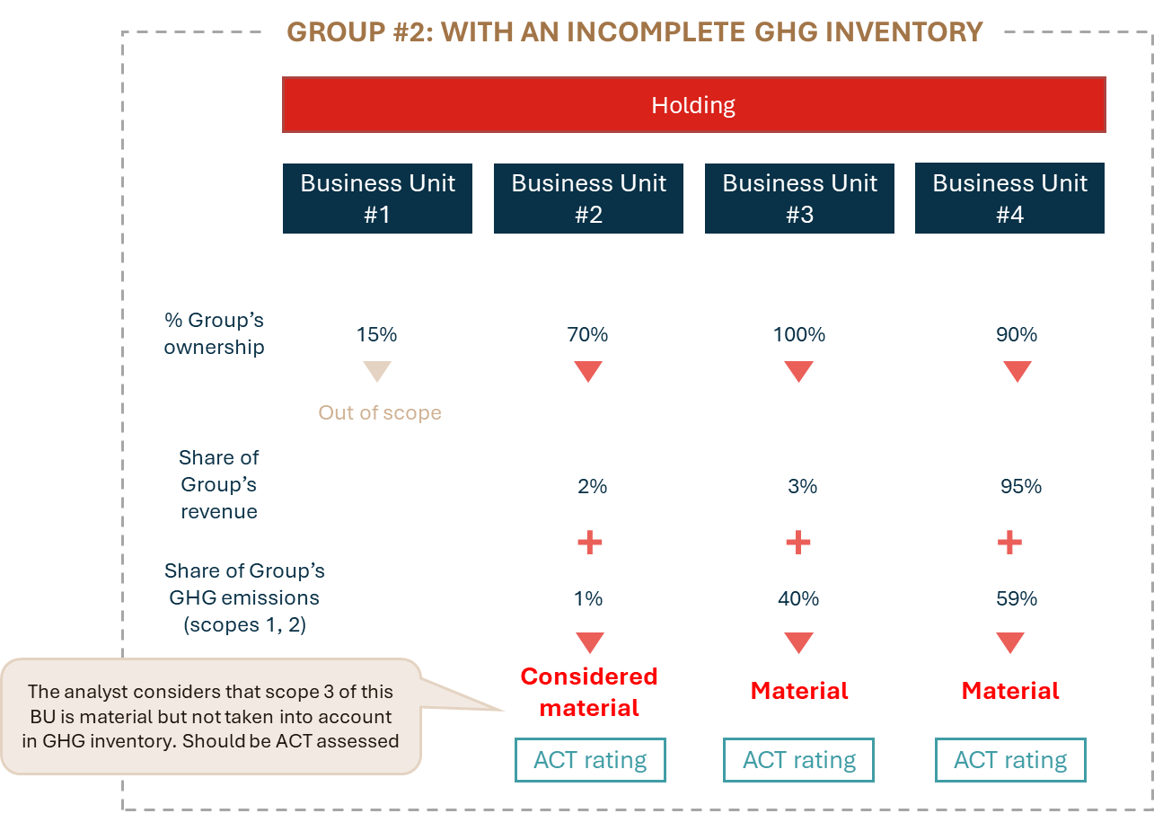
Figure 6 - Definition of ACT assessment scope when GHG inventoty is incomplete

➔ Rationale
- Criteria #1 is based on GHG Protocol guidelines (c.f. Appendix 2).
- Criteria #2: setting minimum material thresholds is part of a pragmatic approach, in order to avoid mobilizing resources for Business Units that are not very material in terms of climate and not very strategic for the group.
- Criteria #3: the goal is to ensure that the large majority of GHG emissions are covered, and that the assessor will not exclude business units that could represent a small share of the turnover but with a high share of the group’s total emissions.

Rule 2: Determination of the type of ACT methodology to use
If the main activities of the business unit correspond to a sector covered by ACT sectoral methodologies (listed in Table #1), the assessor is required to use the corresponding ACT methodology to assess the Business Unit. Otherwise, the ACT Generic methodology should be applied.

Table 1 - ACT sectoral METHODOLOGIES (in 2024)
ACT sectoral methodologies
- Auto
- Building Construction
- Real Estate
- Property Development
- Retail
- Electricity
- Oil & Gas
- Transport
- Cement
- Iron & Steel
- Glass
- Pulp & Paper
- Aluminium
- Chemical
- Agriculture and Agri-food

ACT sectoral methodologies for financial institutions (FIs)
Methodologies differ given the specific characteristics of the financial sector.
- Finance – Banking
- Finance – Investing
Those methodologies focus on financed emissions (thus on the portfolio and not on the FI’s own emissions). They are not to be used in this context as these activities are given a different role in the contribution to Paris Agreement. Please note that FI’s own emissions (for instance through their owned building) can be handled if deemed relevant through an ACT Generic methodology.

➔ Rationale
ACT sector-based methodologies take sector specific features into account, leading to a higher coverage of companies GHG emissions as well as strategic issues, compared to an ACT Generic assessment.

Rule 3: Definition of the modules

The modules of the ACT performance score can be filled out at group level or business unit level, depending on the organization of the group.
For instance, if the group has group-level emissions reduction targets, a unique client policy and a centralized management system, the “Targets”, “Management” and “Client” modules should be scored at group level (using the ACT Generic methodology) and feed the Business Units assessment with these scores. For the other modules, each business unit provide its own data to be assessed.
To conclude, the holding company, which is the highest level of decision in the group, does not implement an ACT data collection process of its own, as it gets an aggregated ACT score of all of the business units it controls (in the scope defined by rule n°1). However, it may intervene in business units’ ACT assessment processes by giving standard content for some modules to all business units.
The graph below presents an illustration where the modules Targets, Management and Policy Engagement are scored with content decided at group level and harmonized among the business units.

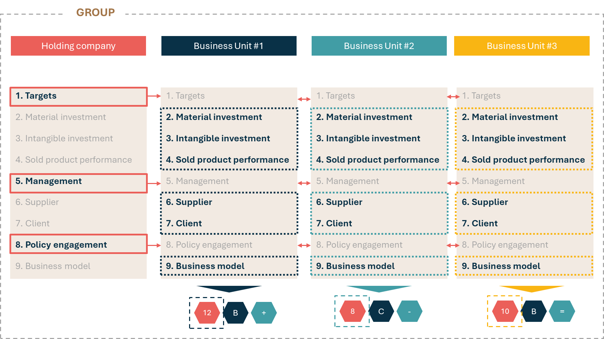
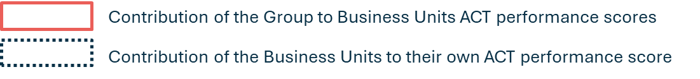
Figure 7 - Illustration of definition of ACT performance score modules

➔ Rationale
- Letting the company decide on how and with what content to feed the ACT data collection process is based on a pragmatic approach: getting as close as possible to the reality of the group (its decision-making process, etc.) and facilitating the logistics of filling out the data collection tables.
- ACT modules correspond to the possible decarbonisation levers of the company. The entity which controls the decarbonisation levers should provide the data for the corresponding modules.

Scope & boundaries at Business unit level

If the business unit has different sub-business units, the three rules defined above can also be followed to clarify the scope of the ACT assessment. In that case, the assessor can decide to:
- Exclude some sub-business units, which do not meet the following requirements (rule n°1):
  - be at least 20% owned by the business unit,
  - represent at least 5% of the business unit’s total revenue and 5% of total business’s total GHG emissions (scope 1+2+3) OR be considered by the assessor as material,
  - In total, 80% of the group’s total emissions must be covered.
- Go for several ACT evaluations (rule n°2),
- Give standard content for some modules to its sub-business units (rule n°3).
If the business unit has several activities (revenue breakdown) but no autonomous sub-entities, only one ACT methodology applies at the business unit level.

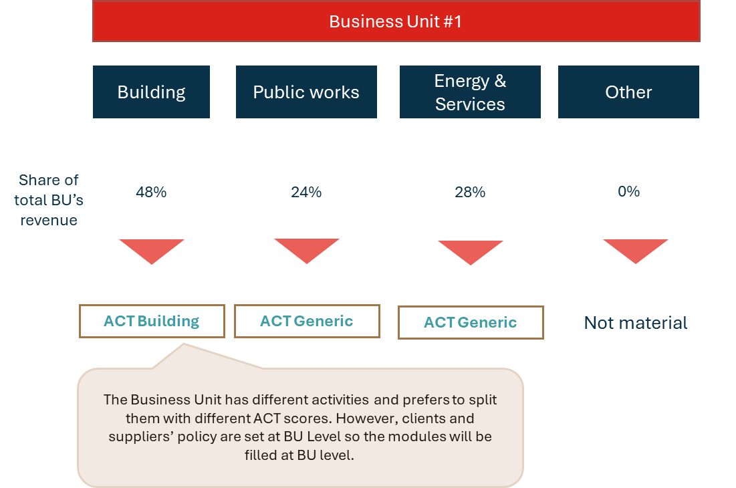
Figure 8 – illustration: Definition of scope at BU level for a Business unit with various activities and autonomous sub-entities

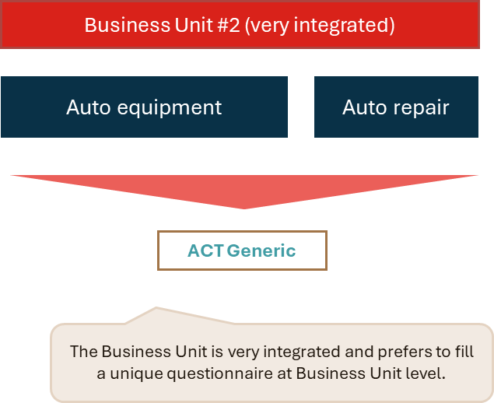
Figure 9 - Illustration: definition of scope at BU level for an integrated business level

Disclaimer: Activities excluded by ACT sectoral methodology, will remain excluded. In that case, the business unit will not be required to cover excluded activities by using ACT Generic methodology, except if the criteria #3 of rule n°1 is not met (reach 80% of group total emissions coverage).

➔ Rationale
Reaching a high level of granularity, through the organization of the business units, aims at capturing as much as possible of the reality of the diversity of the group’s activities.

Scoring consolidation at Group level

Rule n° 4: Consolidation of performance scores based on revenue (adjusted)

The ACT performance scores obtained at business unit level are consolidated (at holding company level) based on their contribution of the group’s total revenue, adjusted from the revenue of excluded activities/business units.
As for the definition of the scope & boundaries, the consolidation methodology is also applied at business unit level if necessary.

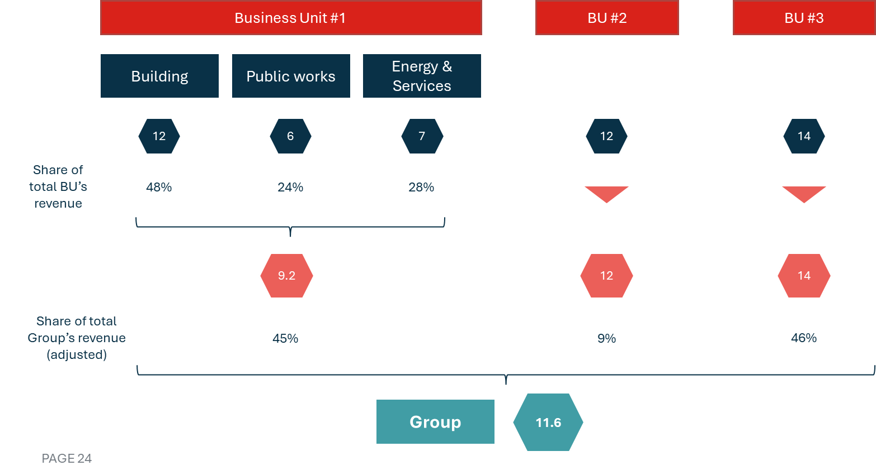
Figure 10 - Illustration of an ACT performance scores consolidation

➔ Rationale
The choice of the revenue as aggregation unit is based on the following reasons:
- This approach is aligned with the EU taxonomy aggregation method (cf. appendix 3).
- Compared to GHG inventory, revenue is always available, complete and robust, which is necessary for consolidation practices.
- GHG emissions are already taken into account in materiality thresholds. An emission intensive business unit generating few revenue will nevertheless fall under the ACT assessment and its score will be disclosed at the end of the process (see 3.2.5 Communication).

Rule n°5: Definition of narrative scores and trend scores
Contrary to performance scores, narrative and trend scores are not aggregated at group level. Each business unit in the scope will be associated with a trend and narrative score. In addition, the group will also get a narrative and trend scores.
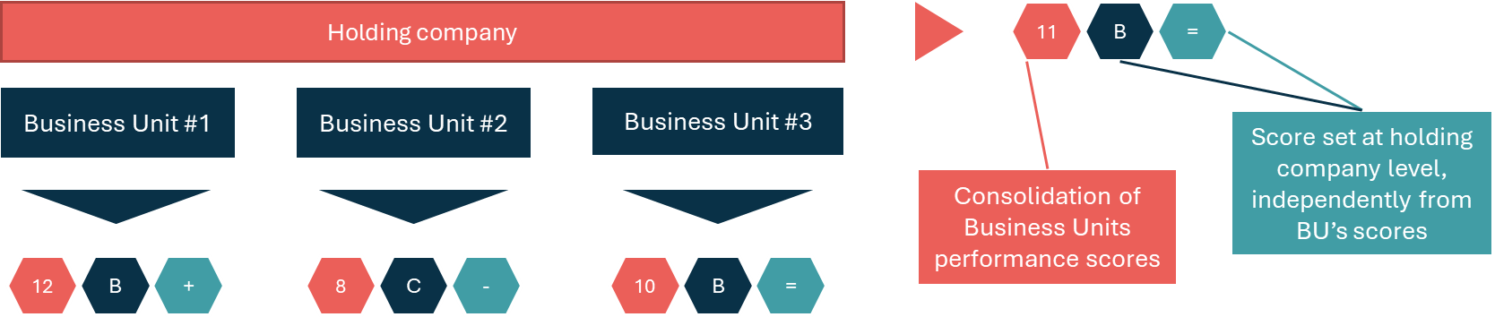

Figure 11 - definition of trend and narrative scores

➔ Rationale
Scores at group and business unit levels provide different and complementary information:
- The narrative and trend scores at group level provide a vision of the risks associated with a low-carbon world according to the "business unit mix" of the group, i.e. the importance of the various business unit activities within the group.
- The narrative and trend scores at business unit level provide a zoom on the specific case of the business unit and the risks & opportunities associated to it.
Besides, the aggregation of such qualitative scores seems difficult and not highly relevant.

Communication
If the results of the multi-activity assessment are publicly disclosed, the communication shall encompass:
- Performance, narrative and trend scores at group level
- Performance, narrative and trend scores at business unit level
- Share of the Group's GHG emissions covered
- Share of the Group’s revenue covered
- The categorisation of the group, based on the consolidated score, according to the ACT categorisation framework.

Glossary

Business unit | A part of a company that operates as a separate part of the whole business. it may or may not have legal status.
Holding company | A company whose main purpose is to control another company or companies through owning shares in it or them.
Multi-activity group | A company whose activities cover several sectors or industries.

Appendix 1 – feedback from ACT roadtests

Case 1: Bouygues Construction
Bouygues Construction is a French construction company and a 100% owned subsidiary of the Bouygues Group.
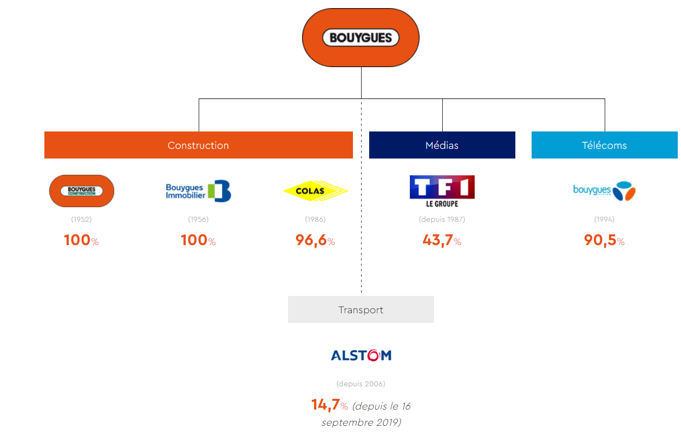
Figure 12 - Bouygues group. Source: Bouygues website
Bouygues Construction operates in several industries, mainly in building, public works and energy. It has eight business units.
Bouygues Construction applied for the ACT Building roadtest. Even though the scope of this sectoral methodology only concerns Bouygues Building, some modules have been filled out at Bouygues Construction’s level. The final ACT score was then attributed to Bouygues Construction even though only one of its business unit (Bouygues Building) was covered.

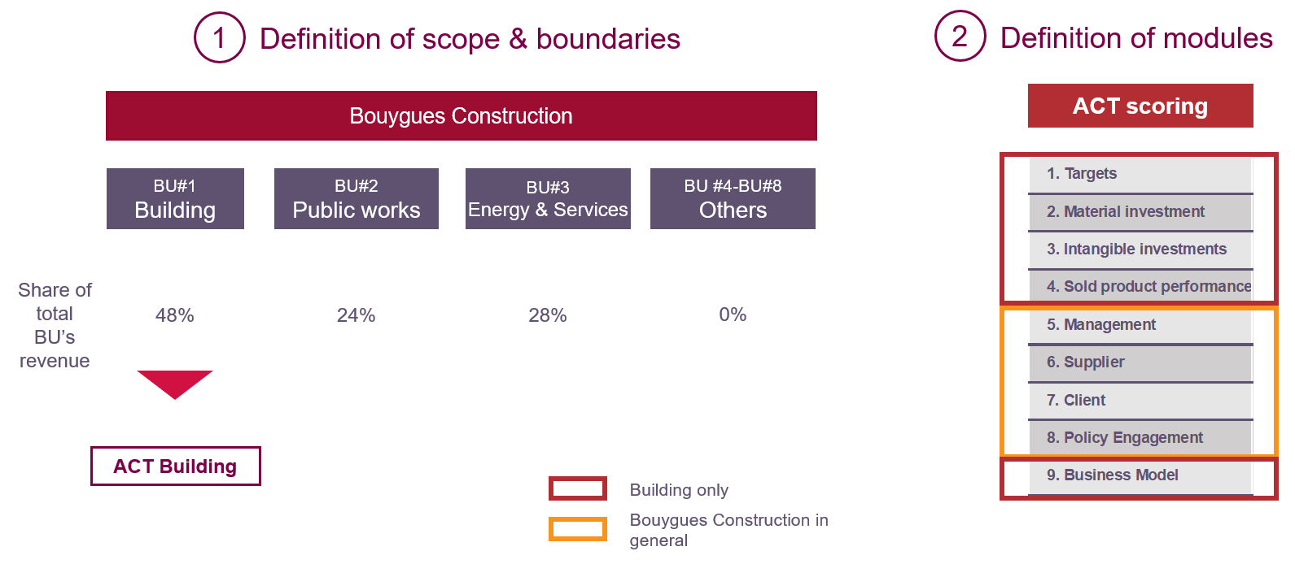
Figure 13 - Bouygues construction case study

Case 2: Vilogia SA
Vilogia SA is a French company which provides real estate services. It offers services of building management as well as renovation and property development. The company applied for ACT Building & Real Estate roadtest. It is very integrated and therefore wanted to get a unique score for the whole group. It has been decided then that only ACT Building will be implemented at Vilogia SA level due to a lack of time to collect data for both methodologies. Some modules have then been filled at Real Estate business unit while others have been filled at Vilogia SA level.

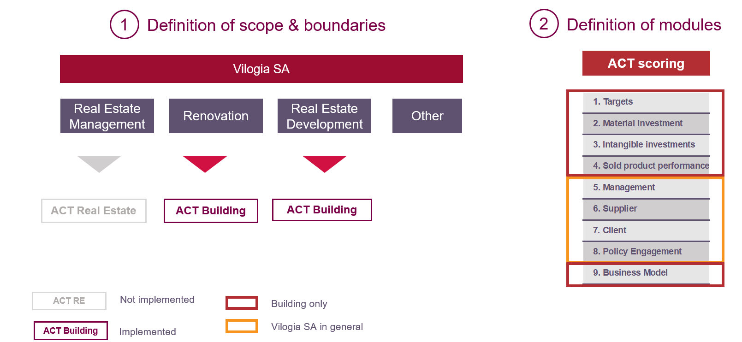
Figure 14 - vilogia sa case study

Lessons learned for Multi-activity rules
Both Bouygues Construction and Vilogia SA cases showed that even though an organization has multiple and diverse activities (under different ACT methodologies), it might be so centralized that half of the modules have to be filled at top level. In that situation, the rule n°3 (definition of modules) gives the flexibility to analyse diverse activities through different sectoral methodologies while reflecting the centralized organization with same content for some modules.

Appendix 2 – Methodological frameworks used

GHG Protocol
GHG Protocol develops standards and guidance on how companies and organizations should account for greenhouse gas emissions and carbon removal.

The mandatory elements to be included in scope 1 and 2 reporting are all the subsidiaries where the company has financial control (> 50% ownership) and significant influence but not financial control (20-50% ownership).
Subsidiaries where the company has no financial control and no significant influence (<20% ownership) may be excluded if justified.
The criteria #1 of the rule n°1 is based on these guidelines.

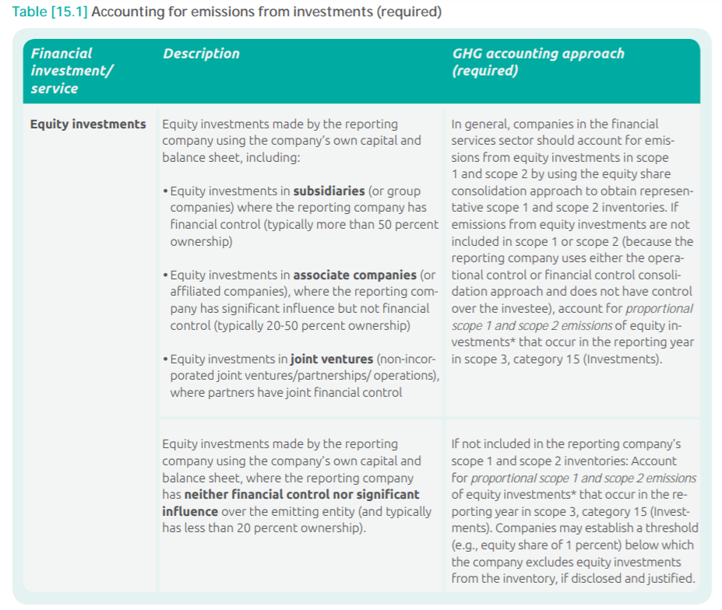
Figure 15 – extract from Technical Guidance for Calculating Scope 3 Emissions, GHG Protocol (2013)

EU taxonomy for sustainable activities

The Technical Expert Group (TEG) on sustainable finance has been asked to develop recommendations for technical screening criteria for economic activities that can make a substantial contribution to climate change mitigation or adaptation, while avoiding significant harm to the four other environmental objectives: sustainable use and protection of water and marine resources, transition to a circular economy, pollution prevention control, and protection and restoration of biodiversity and ecosystems.

The consolidation method used by the EU Green Taxonomy, whether it concerns a portfolio or a group with subsidiaries, always based on turnover breakdown or holding company portfolio breakdown. The rule n°4 is aligned with that approach.

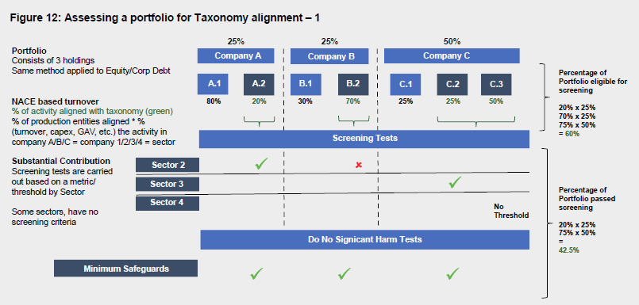
Figure 16 – extract from the Final report of the Technical Expert Group on Sustainable Finance (march 2020)

Corporate Sustainability Reporting Directive (CSRD)
CSRD is a European Union directive that strengthen the rules for companies to disclose information on what they see as the impact, risks and opportunities arising from social and social and governance issues, but also impact of their activities on people and the environment.
Companies subject to the CSRD will have to report according to European Sustainability Reporting Standards (ESRS) ; one of these standards, ESRS E1, is specifically dedicated to climate change. One requirement for the companies is to conduct a materiality assessment to identify the material impacts, risks and opportunities to be reported, and publish if needed its assessment of non-materiality with regards to climate issues. The rule n°1 is aligned with this materiality approach for climate change mitigation.

Reference in Appendix 2
Directive (EU) 2022/2464 of the European Parliament and of the Council of 14 December 2022 amending Regulation (EU) No 537/2014, Directive 2004/109/EC, Directive 2006/43/EC and Directive 2013/34/EU, as regards corporate sustainability reporting
According to the Paris Agreement, Article 2.1c, which states the objective to “[make] financial flows consistent with a pathway towards low greenhouse gas emissions and climate-resilient development”. Finance Institutions shall play an indirect yet crucial role to contribute to a deep transformation of the world economy.
ACT Assessment categorisation, V0.1, April 2024
https://ghgprotocol.org/
https://ec.europa.eu/info/business-economy-euro/banking-and-finance/sustainable-finance/eu-taxonomy-sustainable-activities_en
Directive (EU) 2022/2464
Delegated Regulation (EU) 2023/277

